**Data Manipulation and Reporting with Power BI**

**High Level Business Requirement:**

Zomato is a restaurant search and discovery service. Operating in several countries worldwide, they provide detailed information and customer reviews of various restaurants. The owners of Zomato, want to unearth the hidden anomalies in their business data. The final objective is to analyze the data in a way which helps them to accurately judge their business performance.

The data (sample) is currently available in the form of a few excel files with each file containing information about several restaurants operating in a specific continent. The clients want to create a consolidated and interactive PowerBI report from where they can easily analyze the following information:

1) Total number of restaurants across continents, countries and cities.

2) The ability to view information at a global level. But at the same time, the ability to go down to a granular level as well.

3) Top performing restaurants by average customer ratings.

4) Top performing restaurants by least average cost.

5) Ability to filter and view the restaurant details (address, cuisines served …) on the basis of:

a. Geographic dimensions like continent, country and city.

b. If the restaurant offers services like, online delivery or table booking.

c. Rating colors denoting the average rating slab.

6) Top ranking restaurants by the number of cuisines they serve.

7) They want to create a multi-page report which matches with the company’s theme and where navigation between pages has been made very easy.

8) They want their users to be able to access this report using a web browser as well as their phone devices.

**Aim of this project:**

The goal is to create a comprehensive, interactive PowerBI report that would enable Zomato to evaluate the necessary data fast.

1. **Data Import:**
2. Import the data from all available Excel files.

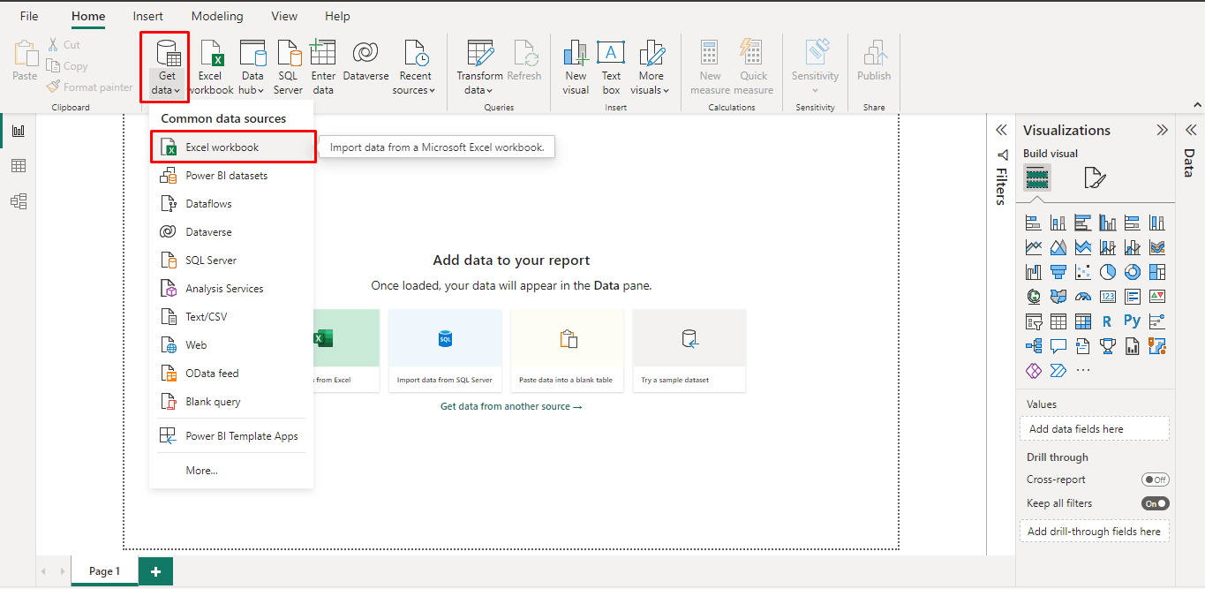

* To get data in the form of excel file first we need to select the get data option from the home tab select excel workbook option from in it.

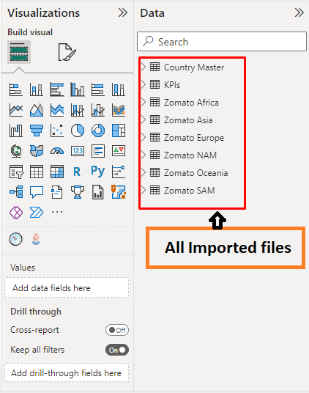

1. **Data transformation:**

To reduce the amount of time needed for transformation and prevent having too many associations in the model, I initially chose to create a new table with the name **Zomato World** using the data from all Zomato areas.

**2.1 To create a single table, I use append query from Home tab.**

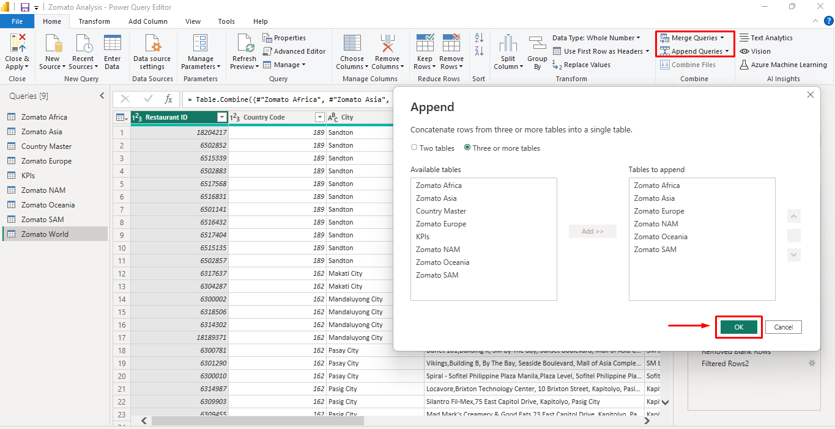

Select all Zomato areas table and make it One Zomato World table.

**2.2 Replace value**:

* Delete “City”.
* Replace “Sí£o Paulo” - “São Paulo”.
* “Cedar Rapids/Iowa City” - “Cedar Rapids”.
* “ÛÁstanbul” - “Istanbul”.

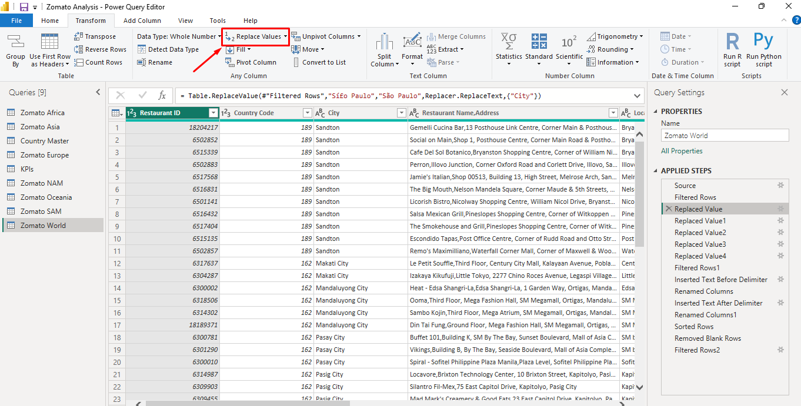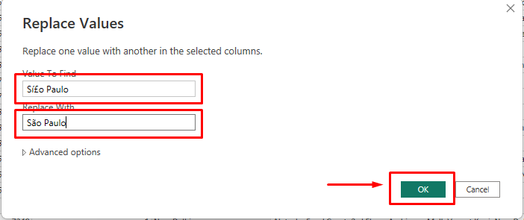

**2.3 Remove unused column:**

I delete Locality and Locality Verbose column from data.

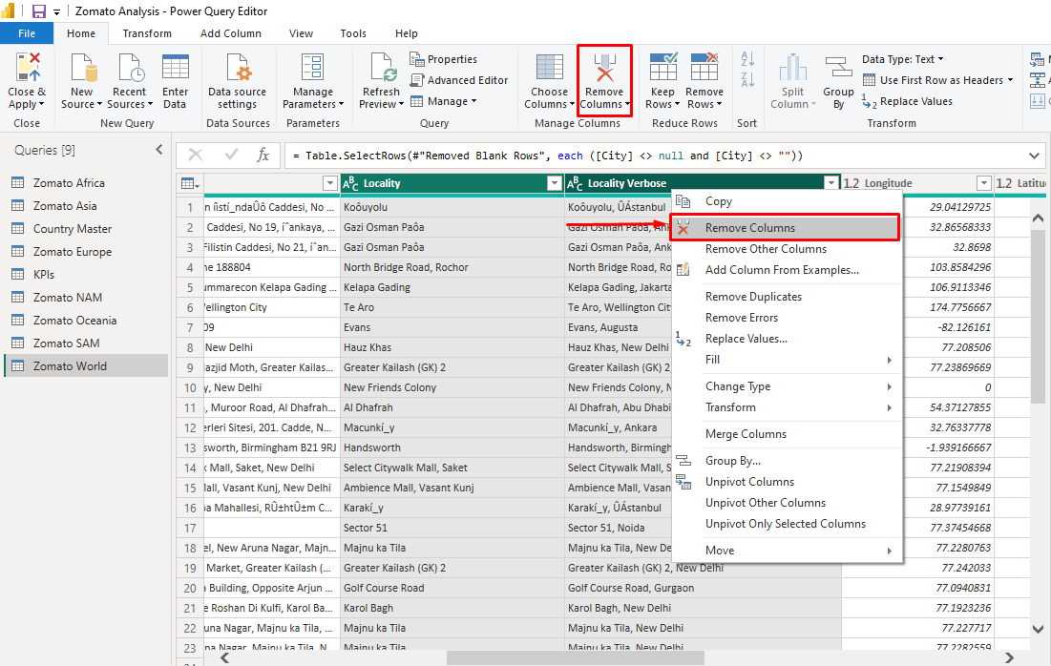

**2.4 Add two column “Restaurant Name”, “Restaurant Address”:**

Here I add two new column based on Restaurant Name, Address. First we go to Add column tab then select Exact and then text before delimiter to separate Restaurant Name and Address.

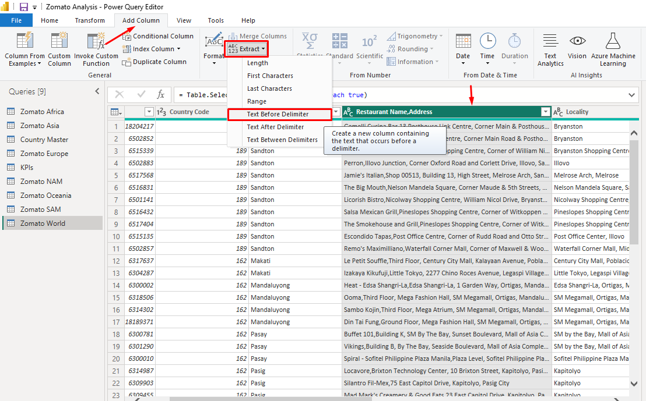

**2.4 Create a new table Name Restaurant Menu:**

I create a new table from Zomato World table with this formula:

**Restaurant Menu = SELECTCOLUMNS('Zomato World','Zomato World'[Restaurant ID], 'Zomato World'[Restaurant Name], 'Zomato World'[Cuisines])**

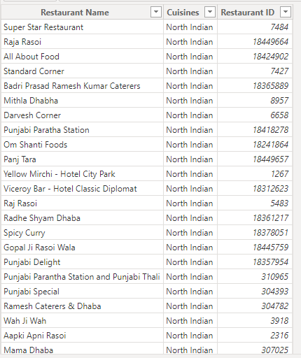

**2.5 Remove duplicate country code:**

I use remove duplicate function to remove duplicate value from country code.

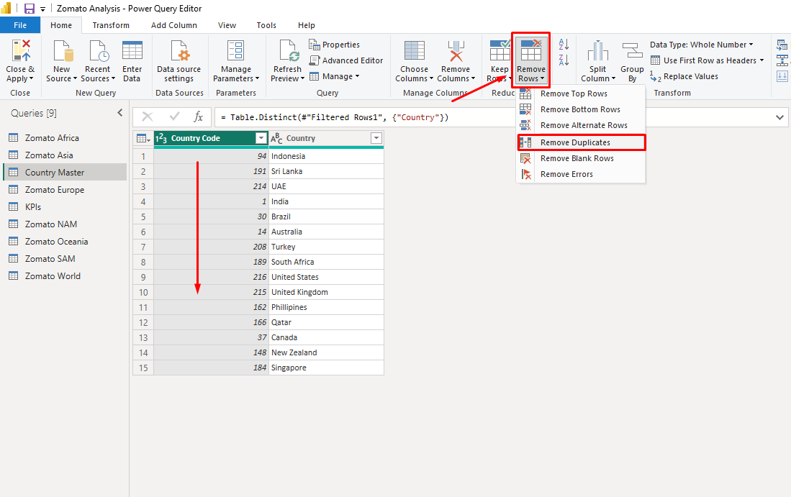

1. **Data Modelling:**

I create data model as per requirement. Here

* Restaurant Menu and KPI connect with Restaurant ID with one to one relationship.
* KPI and Zomato World connect with Restaurant ID with one to one relationship..
* Country Master and Zomato World connect with country code with one to many relationship

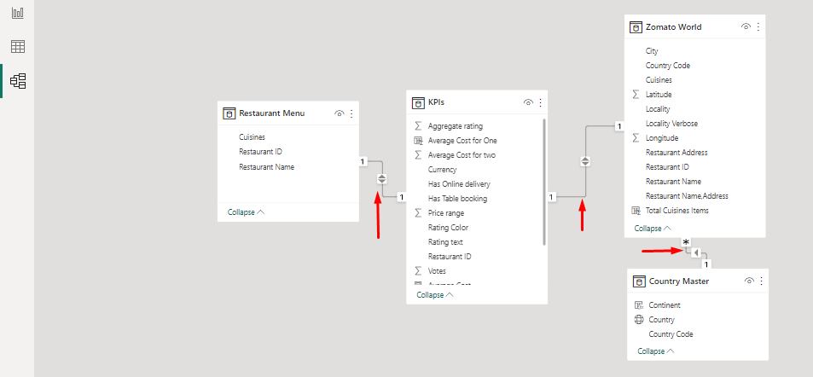

1. **Using DAX:**

**4.1** I created a conditional column which name is Rating Column based on below data:

**Aggregate rating** **Rating color**

Above 4.5 Dark Green

4 to 4.4 Green

3.5 to 3.9 Yellow

2.5 to 3.4 Orange

1.8 to 2.4 Red

0 to 1.7 White

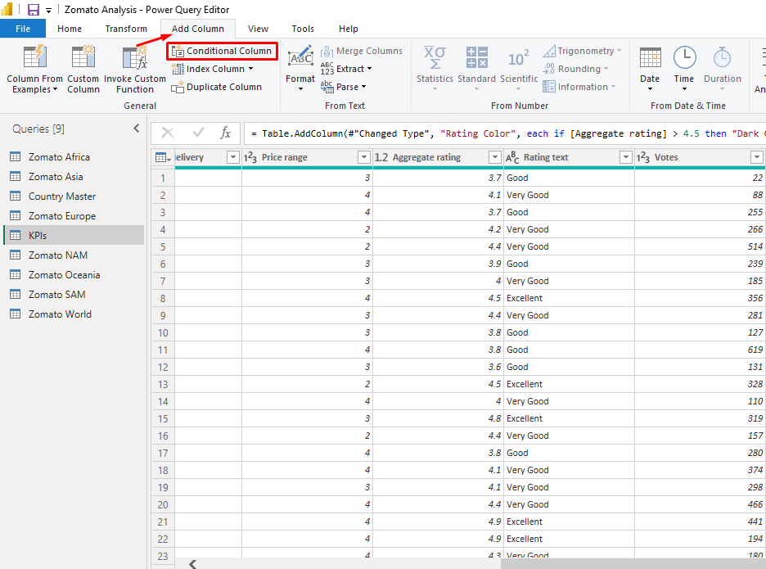

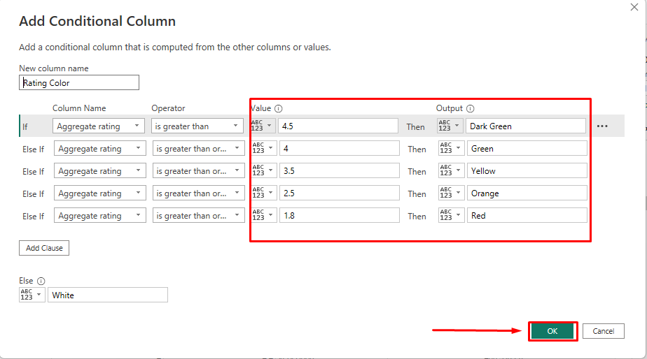

From data tab column tools from column tools select tab new column and write the DAX formula

**4.2**. Create **Restaurant Count** measure with dax formula:

**Total Restaurant = DISTINCTCOUNT('Restaurant Menu'[Restaurant ID])**

**4.3** Create **Average Cost** measure with dax formula:

**Average Cost = AVERAGE(KPIs[Average Cost for two])**

**4.4** Create **Average Rating** measure with dax formula:

**Average Rating = AVERAGE(KPIs[Aggregate rating])**

**4.5** Create **Cuisine Count** measure with dax formula:

**Total Cuisine = DISTINCTCOUNT('Zomato World'[Cuisines])**

**4.6 Create a new column called “Continent” in the “Country Code” table with this formula:**

**Continent = IF('Country Master'[Country]=="Indonesia", "Asia",**

**IF('Country Master'[Country]=="Sri Lanka", "Asia",**

**IF('Country Master'[Country]=="UAE", "Asia",**

**IF('Country Master'[Country]=="India", "Asia",**

**IF('Country Master'[Country]=="Brazil", "South America",**

**IF('Country Master'[Country]=="Australia", "Oceania",**

**IF('Country Master'[Country]=="Turkey", "Asia",**

**IF('Country Master'[Country]=="South Africa", "Africa",**

**IF('Country Master'[Country]=="United States", "North America",**

**IF('Country Master'[Country]=="United Kingdom", "Europe",**

**IF('Country Master'[Country]=="Philippines", "Asia",**

**IF('Country Master'[Country]=="Qatar", "Asia",**

**IF('Country Master'[Country]=="Canada", "North America",**

**IF('Country Master'[Country]=="New Zealand", "Oceania","Asia"**

**))))))))))))))**

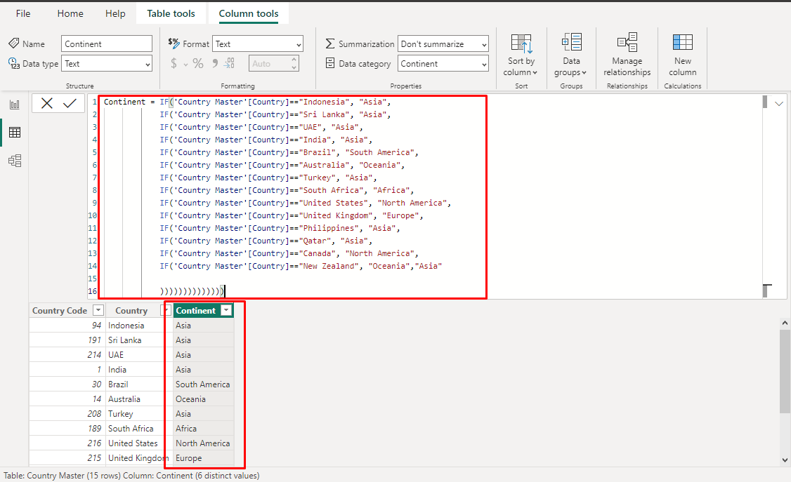

**4.7** After that II categorized continent, city data to expected data type.

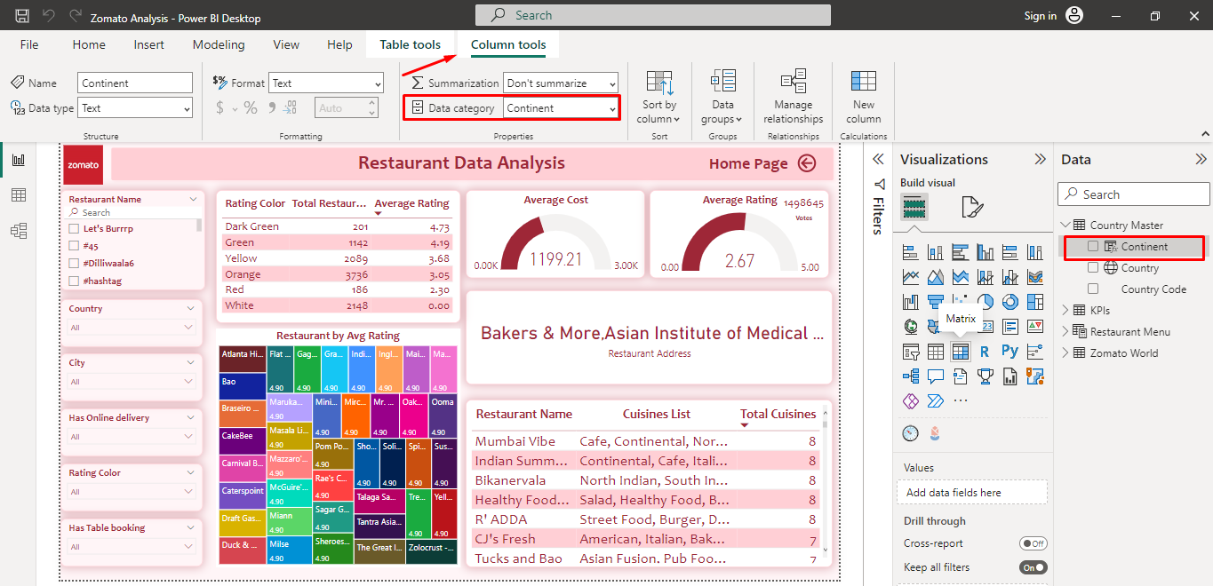

1. **Data Visualizations:**

**5.1 Card Visual:**

I created Total **Restuarant Count**, **Average Cost**, **Average Rating** with card visual

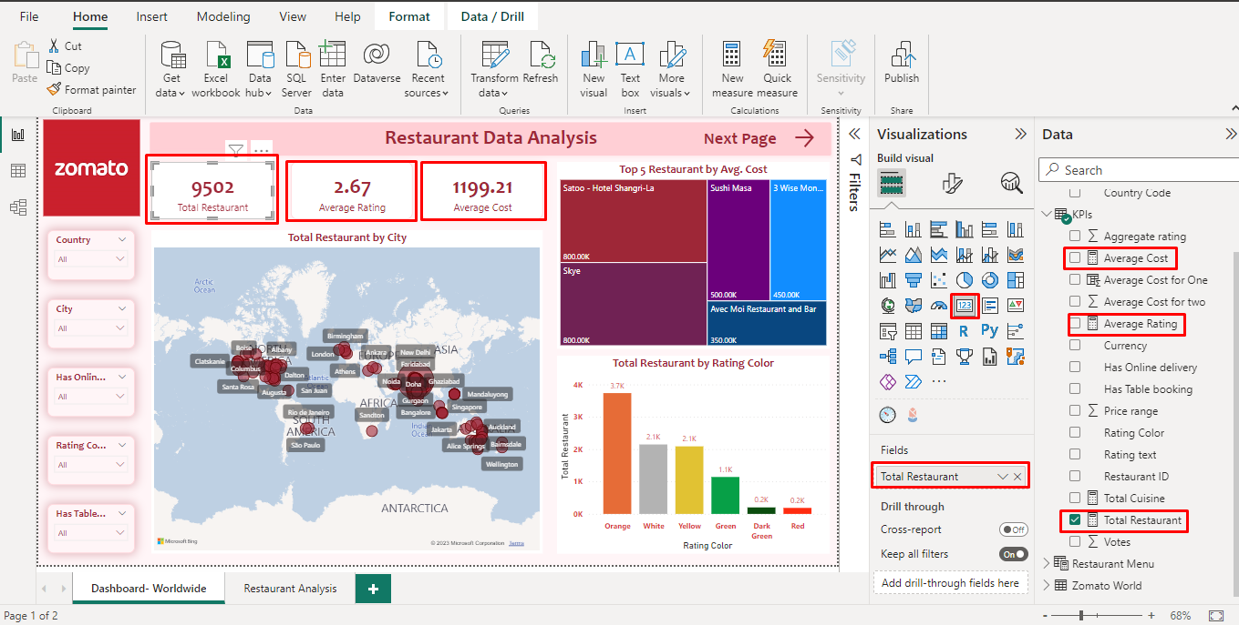

**5.2 Map visual:**

I create a map visual where you can find Geography hierarchy and total restaurant. Here there is option tw drill down to find out total no of restaurant in continent, country and city.

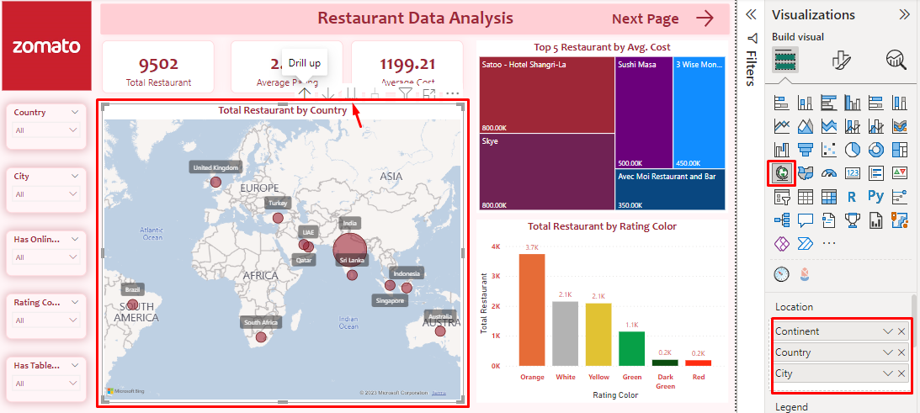

**5.3 Infographic designer:**

In dashboard we have some infographic design where we can easily visualize Restaurant Name, Top 5 Restuarant by Average Cost and rating.

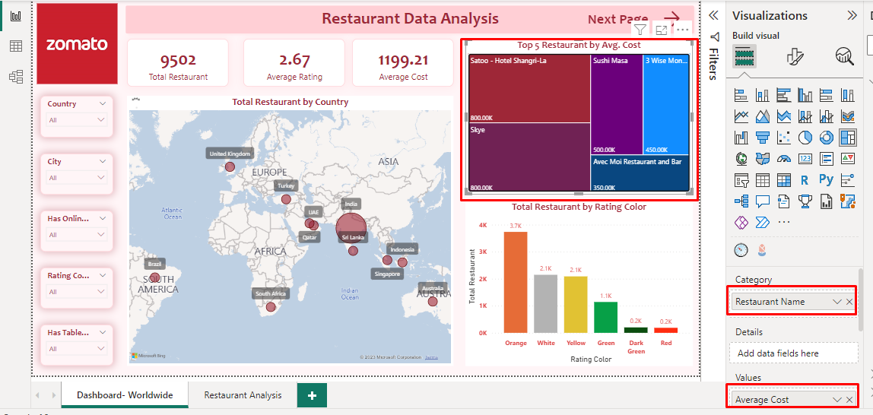

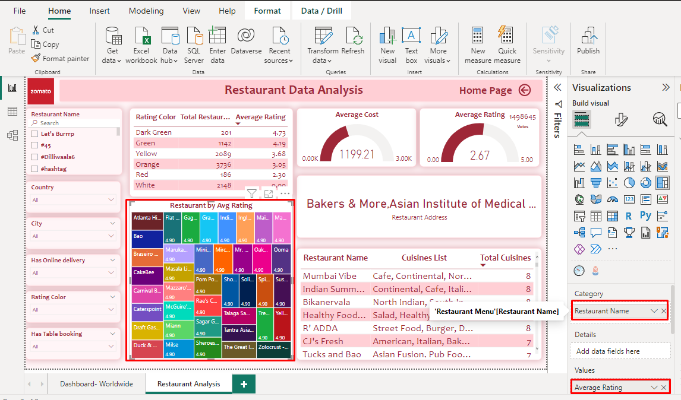

**5.4 Slicer:**

We added different types of filter here. There is restaurant name, city, Rating color and so on. You can also search here your text.

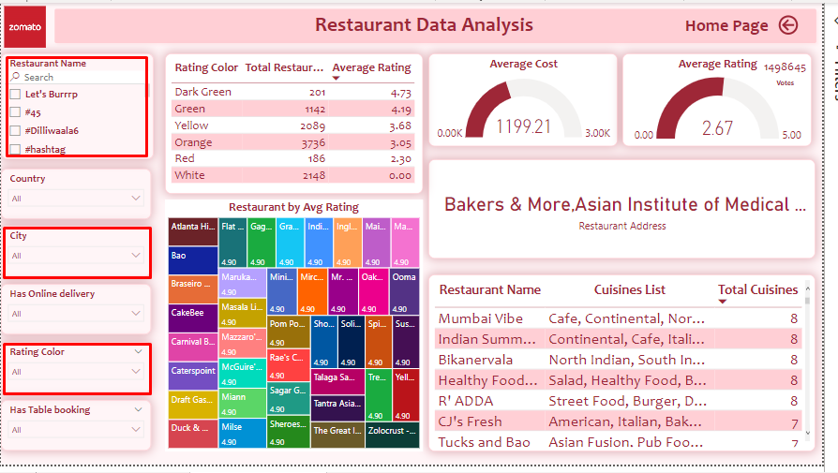

**5.4 Table and Gauge :**  In table you can see Restaurant Name, Cuisines List and Total Cuisines. And in gauge Average Cost and Average Rating is showing.

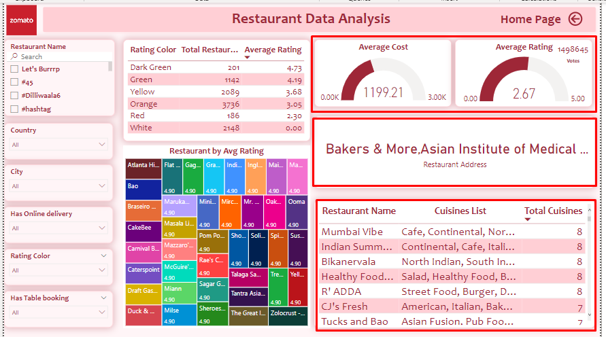

**End**